# Task 2 For DevOps:

1. **Installation of Docker:**

**Code:**

sudo apt install docker.io

docker –version

sudo systemctl start docker

sudo systemctl status docker

sudo systemctl enable docker

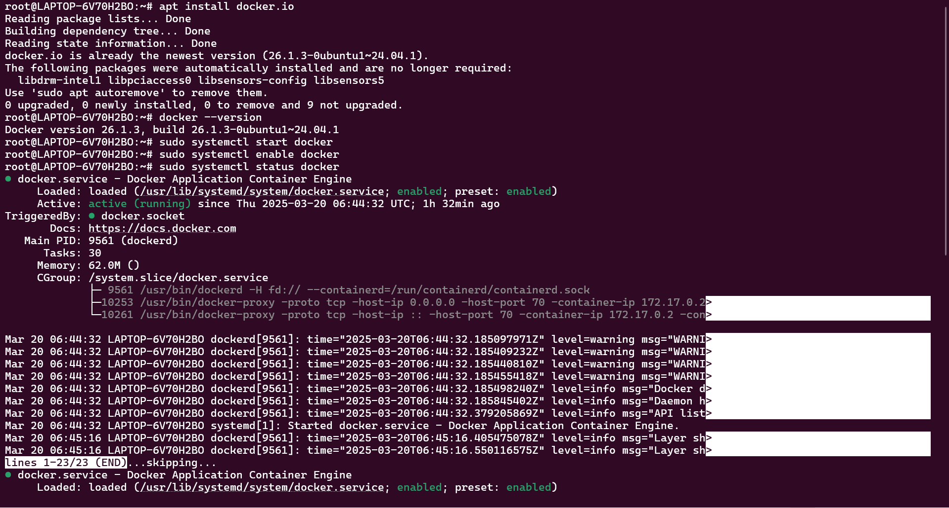

1. Fork a copy of a Github repo which contains the necessary files

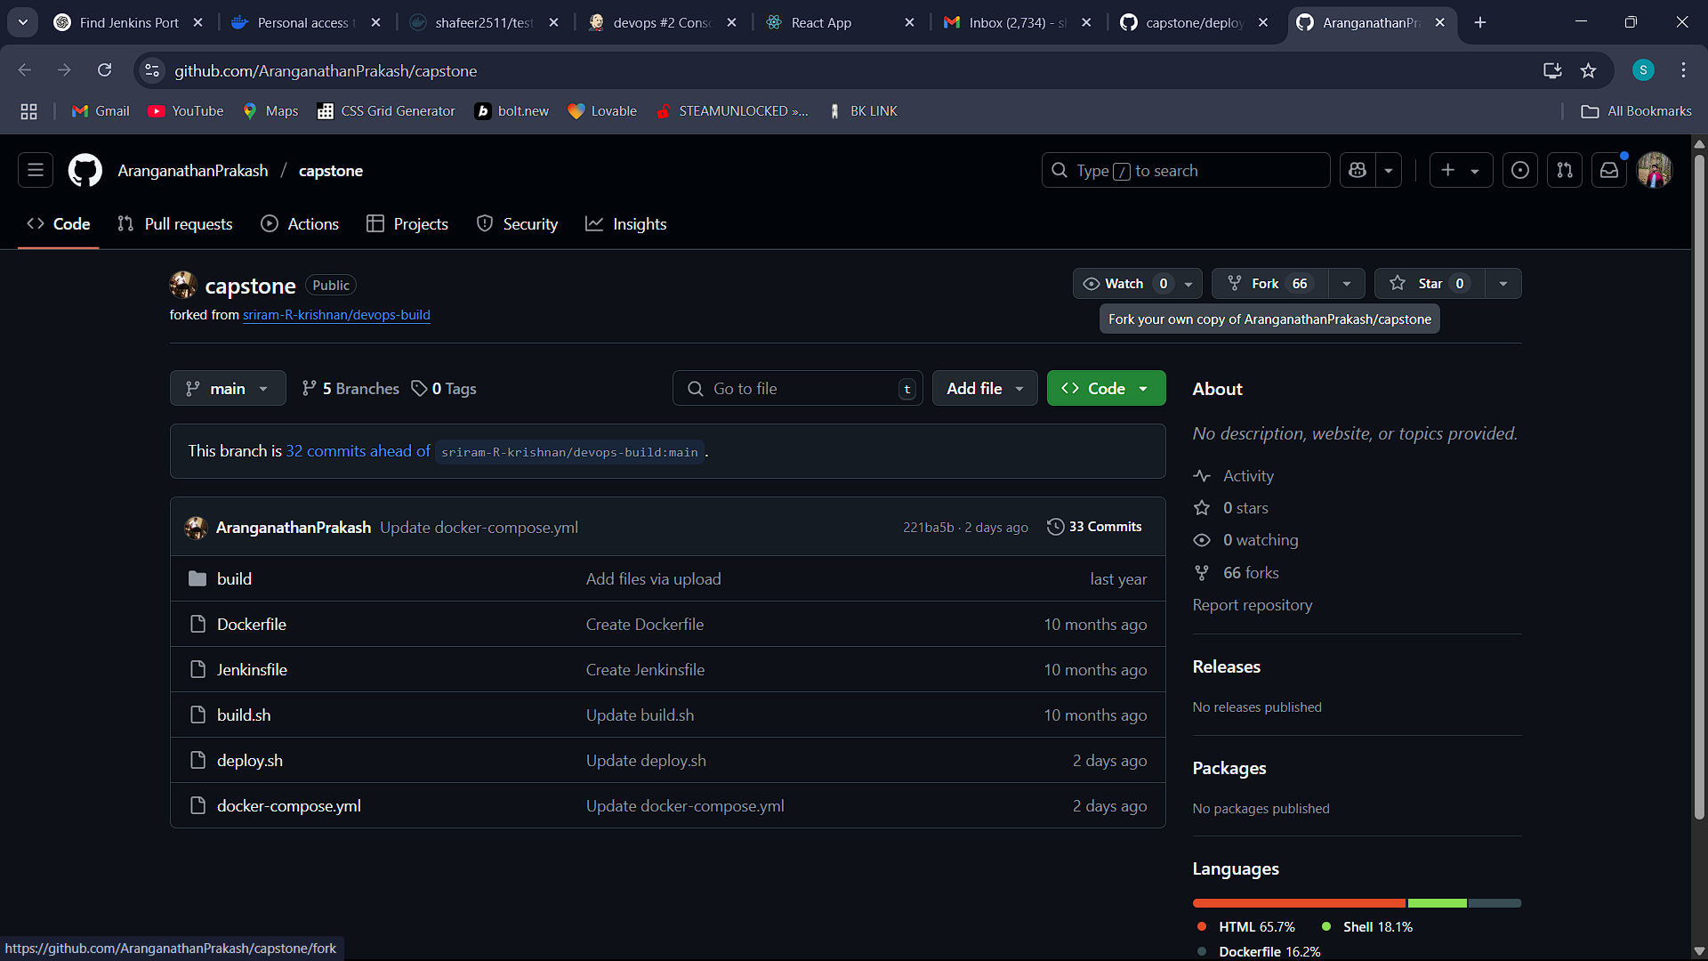

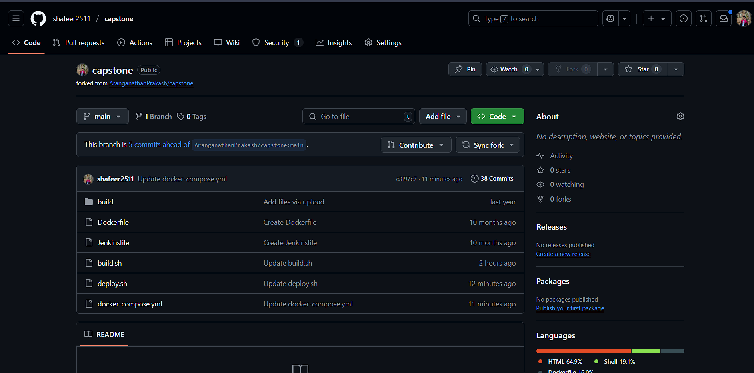

1. Then edit the deploy.sh file and enter the corresponding username and tokens

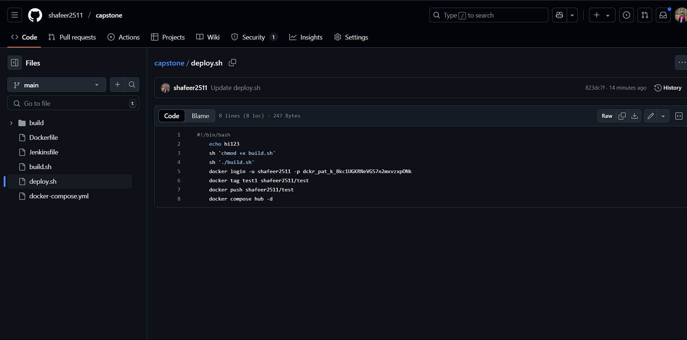

1. Copy the GitHub link of the repository and go to Jenkins to create a pipeline project

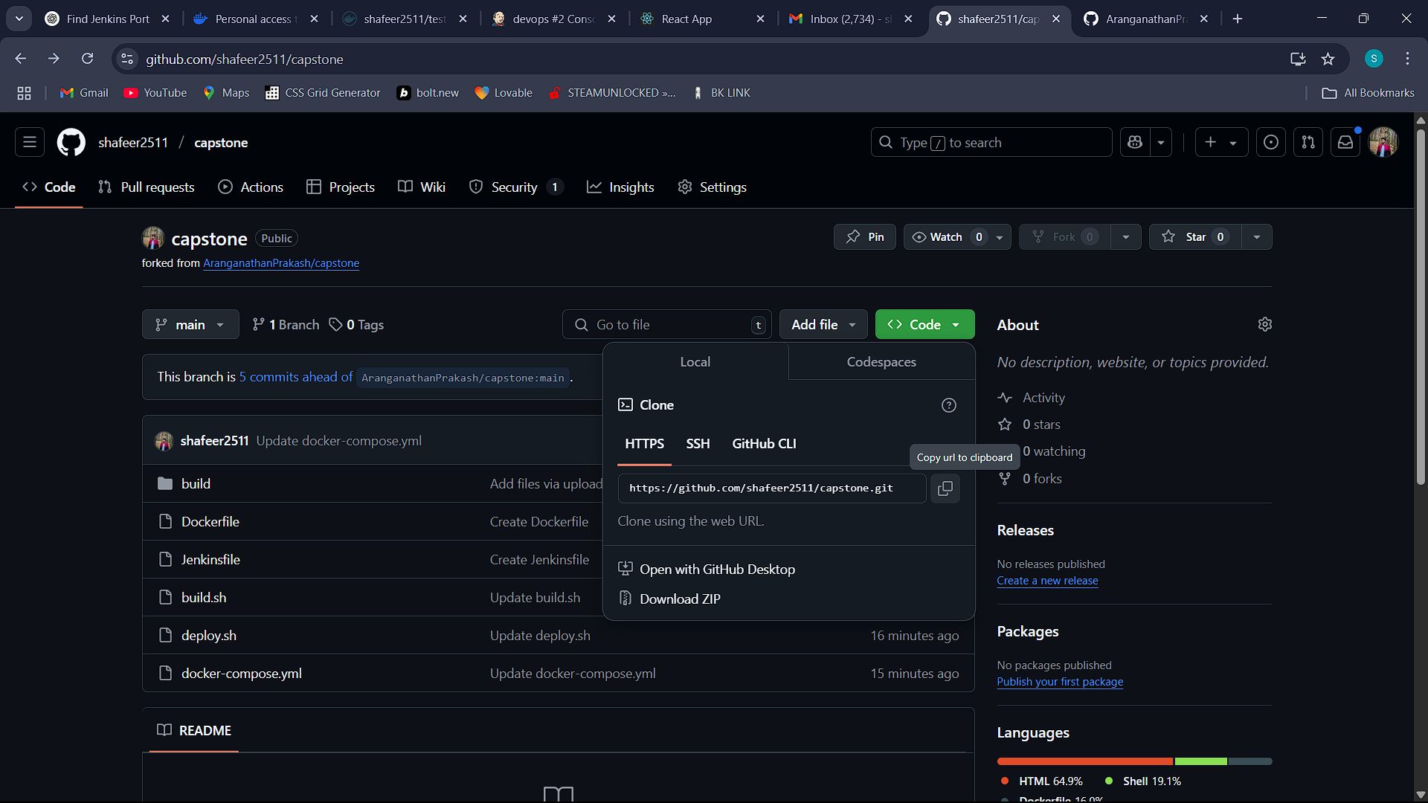

1. In Jenkins create a new item(Job) with a pipeline type and add the Git URL to the respective branch and Jenkinsfile

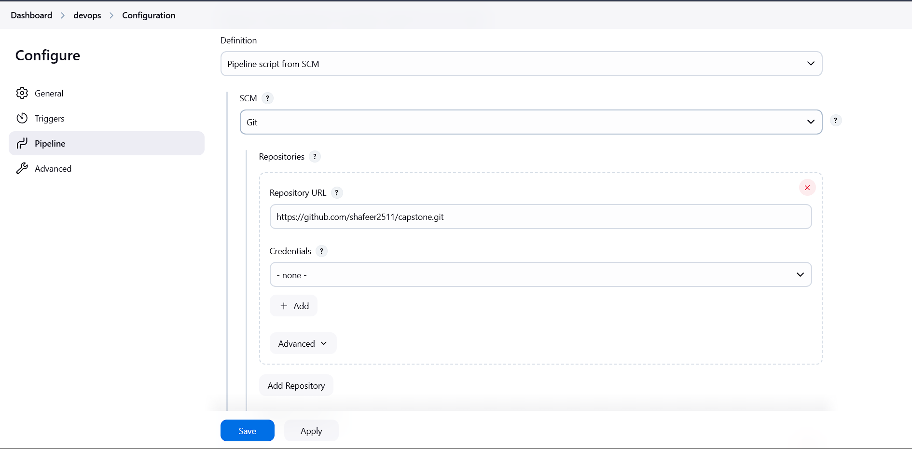

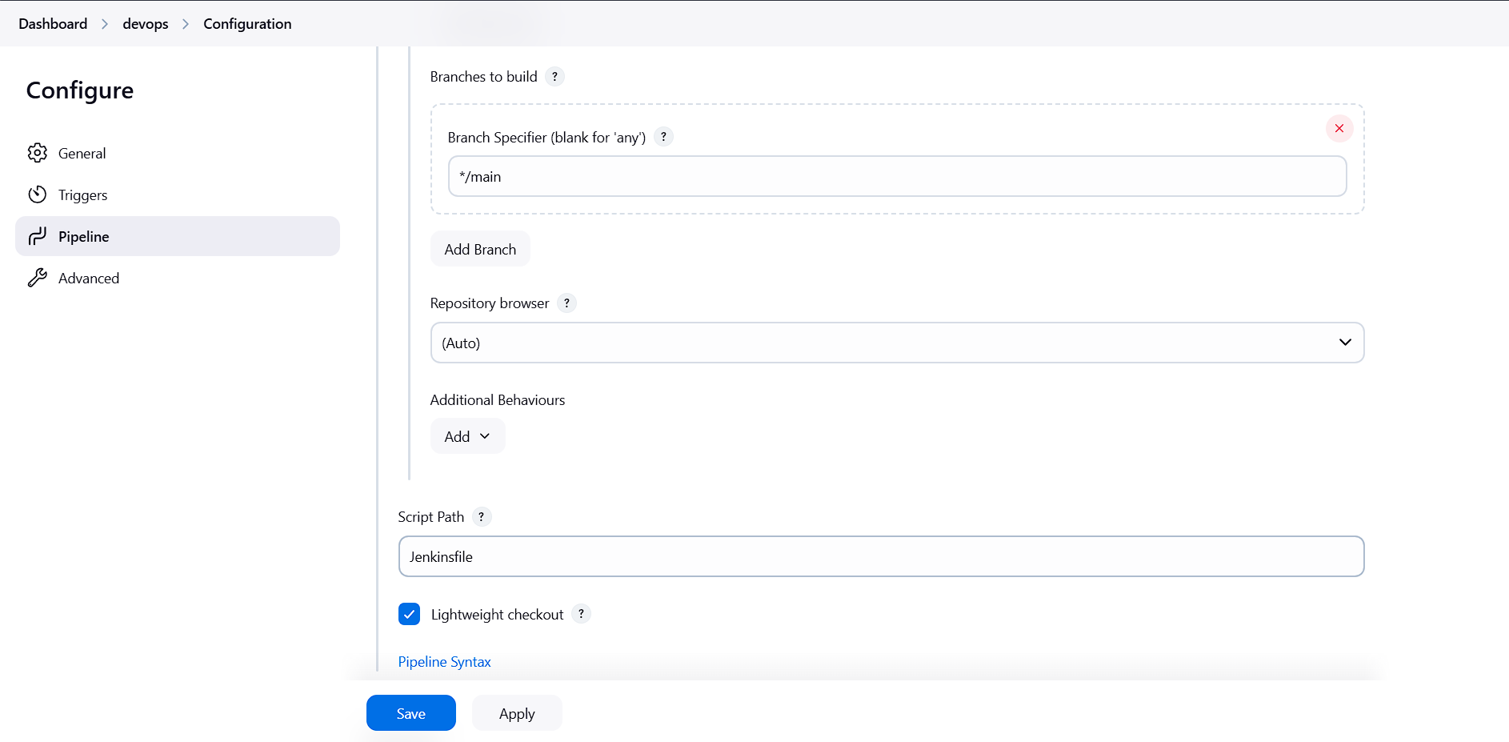

1. After creating the job, build it and it will give the console output and the docker image will be created.

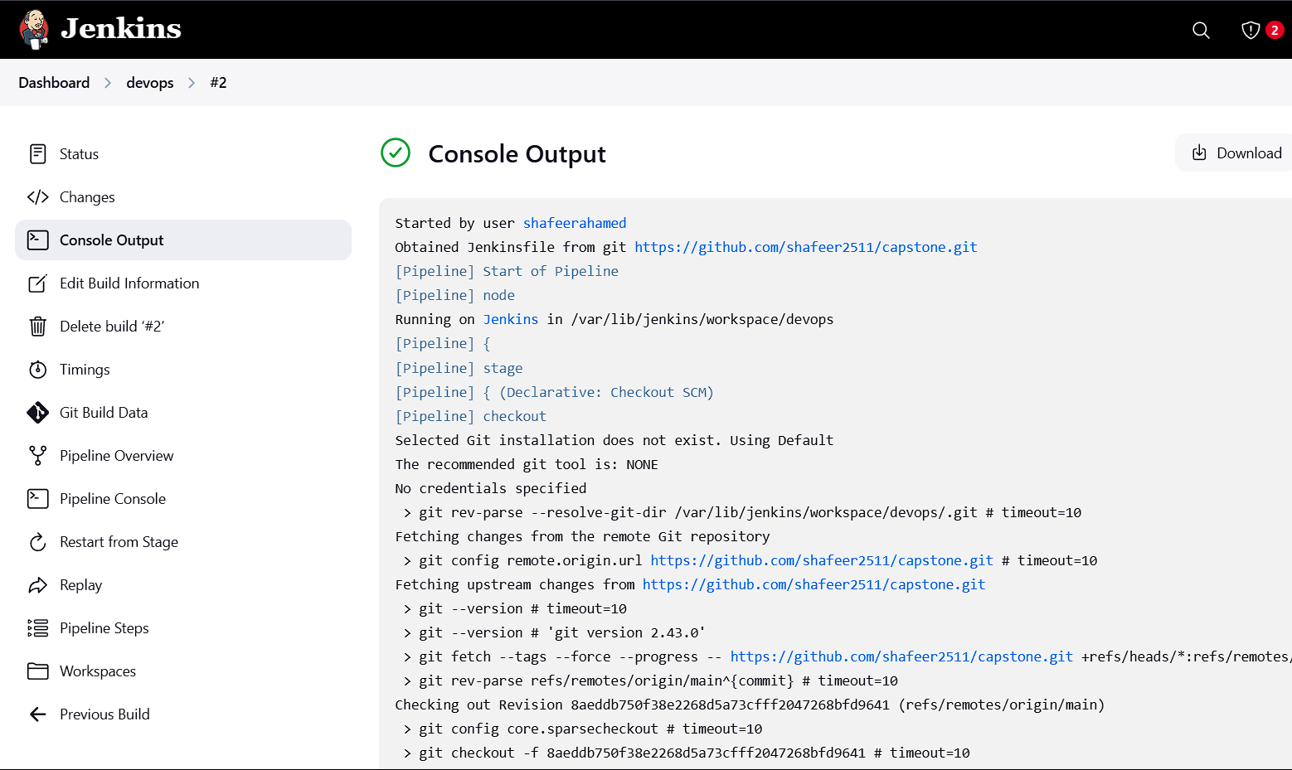

1. Now attach the desired port number to the build image

**CODE:**

docker images

docker build -itd -p 70:80 test1

**ScreenShot:**

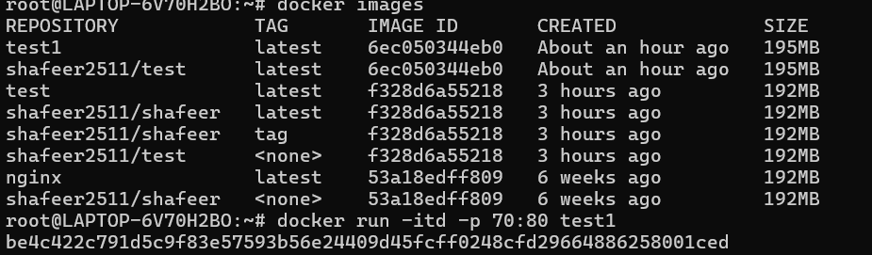

1. Go to the Browser and search for localhost:<PORT_NUMBER> and the respective website will be hosted

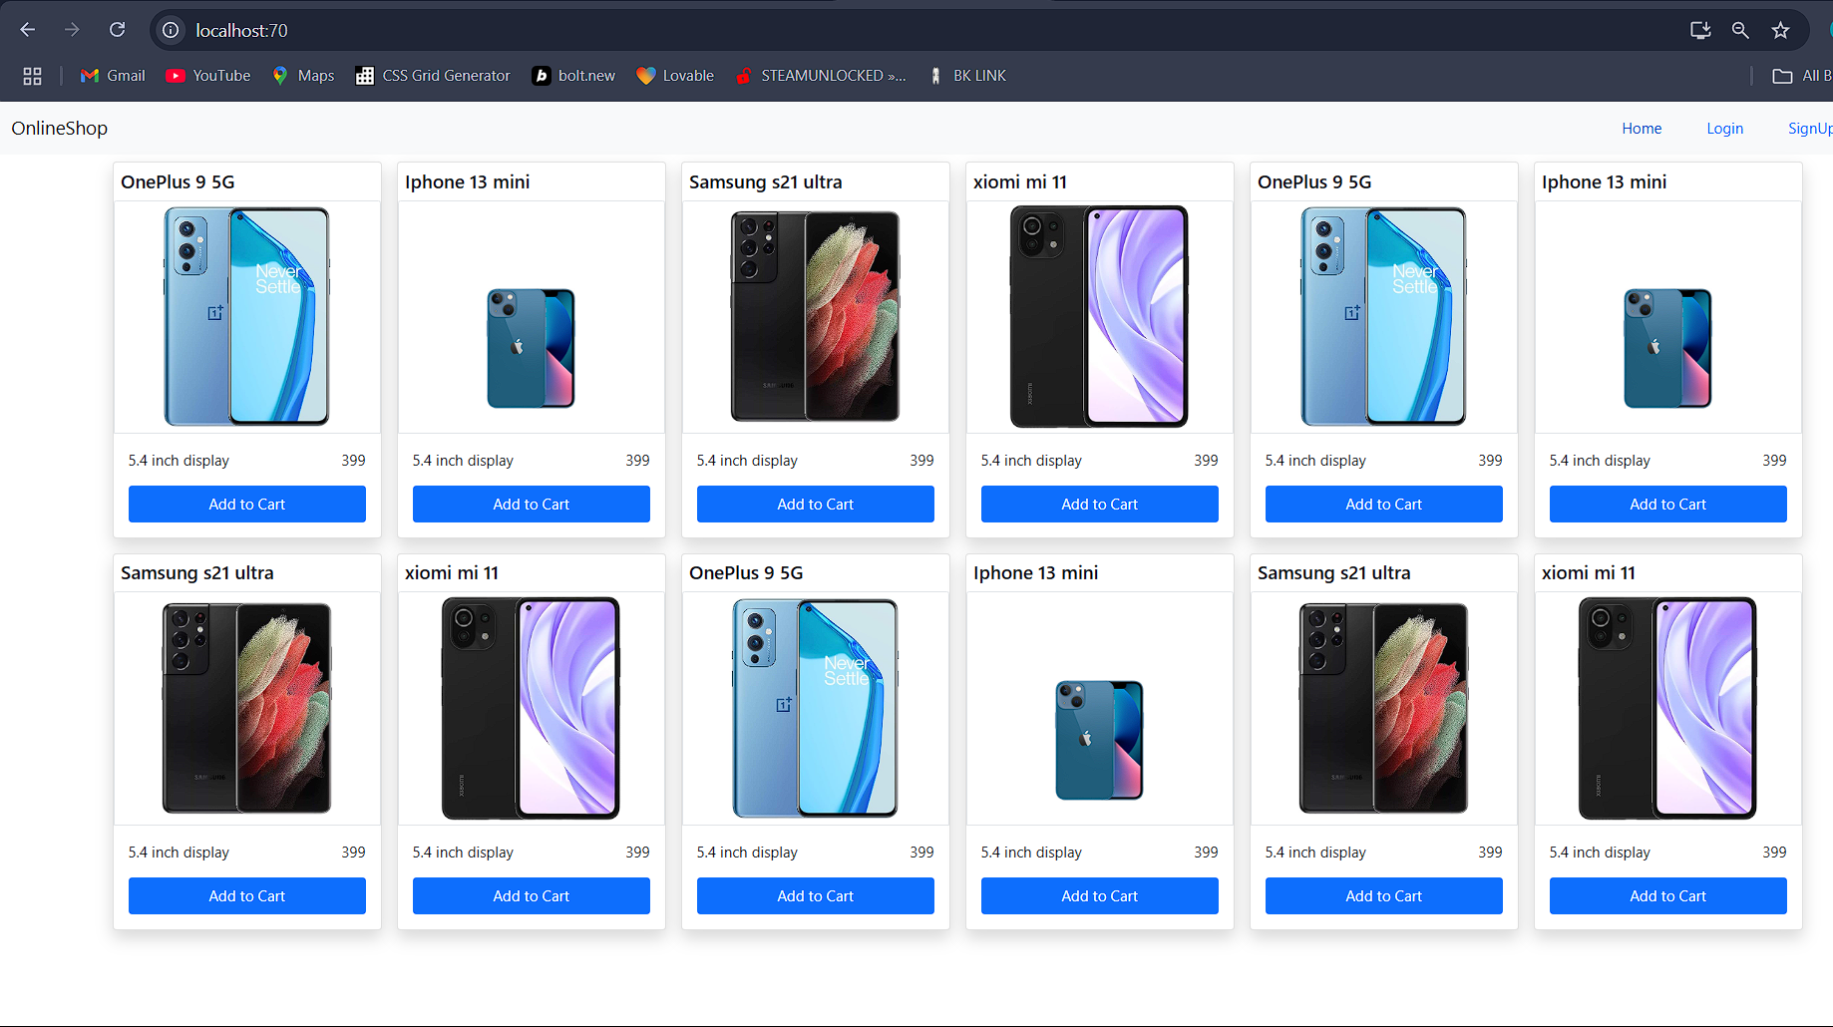

1. But, Instead of of running the image manually, we can also write the command for running in a file called docker-compose.yml

**Code:**

version: '3'

services:

react-capstone:

image: "test1"

ports:

- "85:80"

**ScreenShot:**

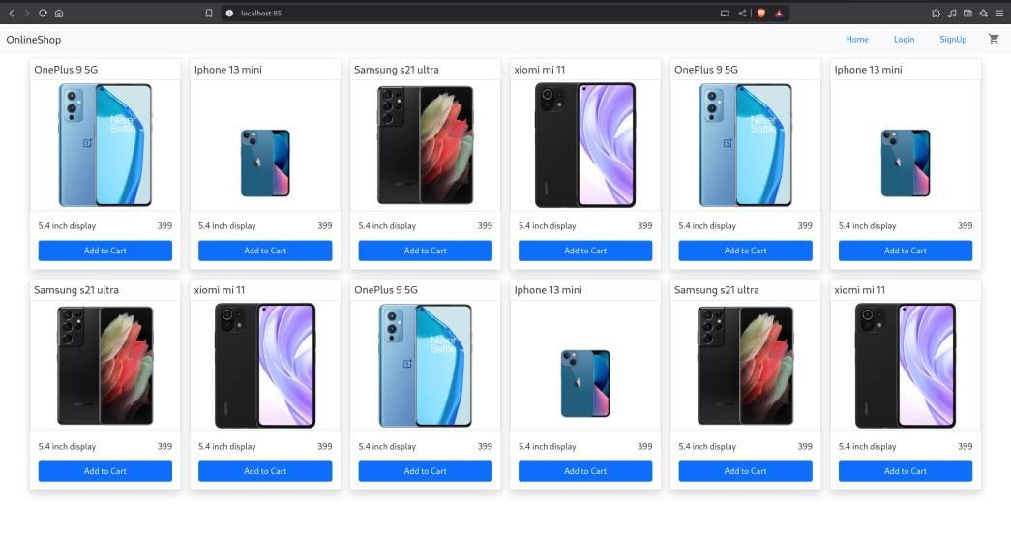

By Creating this, we no need to run the image by manually. (It will automatically run)

1. Adding Webhook to it which is available in GitHub for automatic build of the project. Installing ngrok and with these command to get the Webhook Link.

**ScreenShot:**

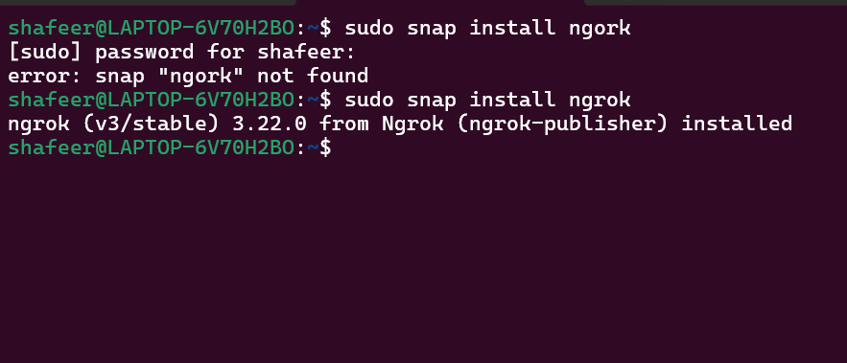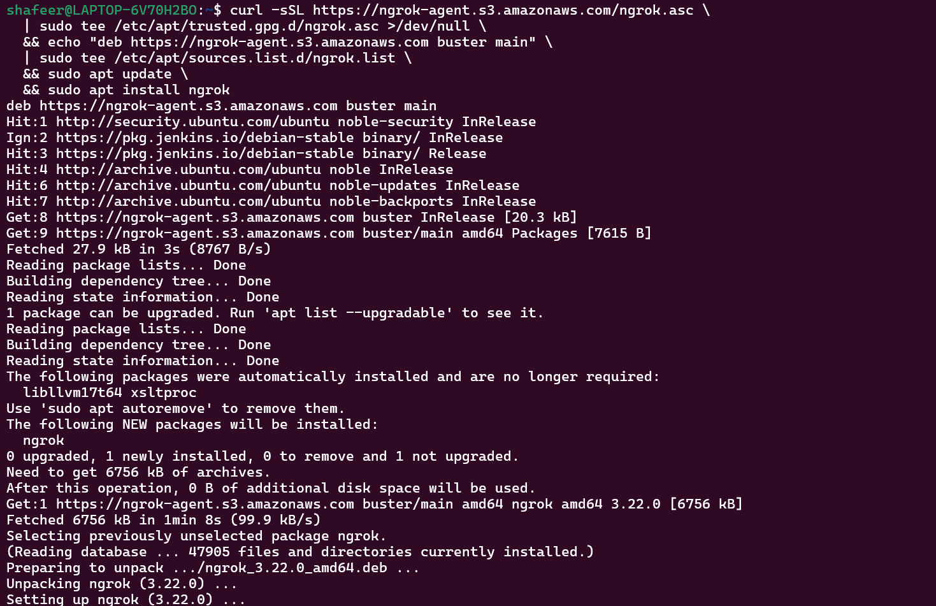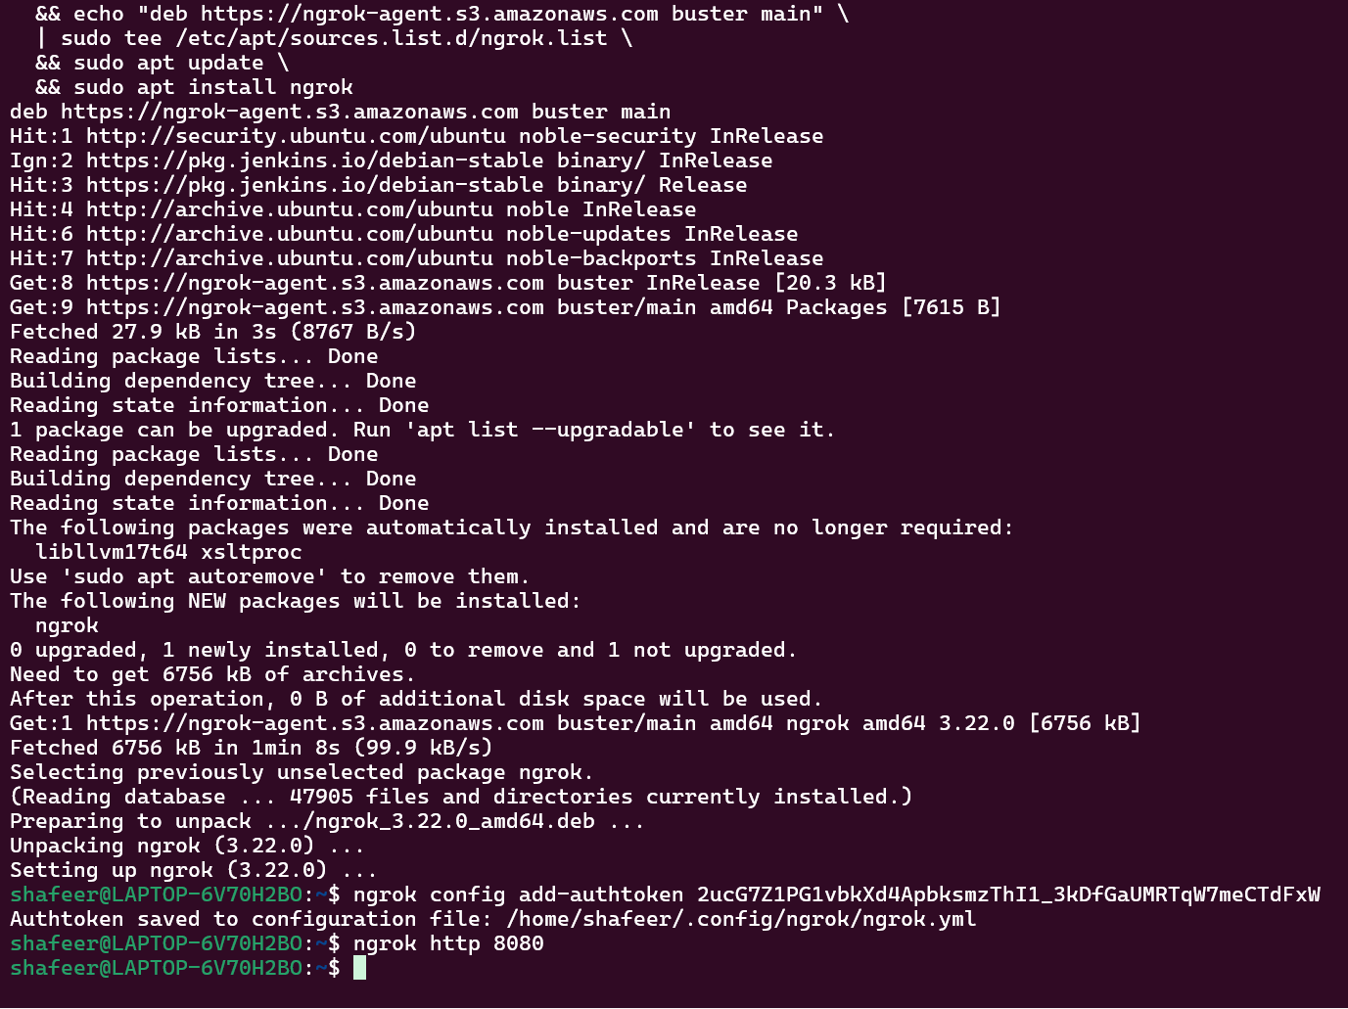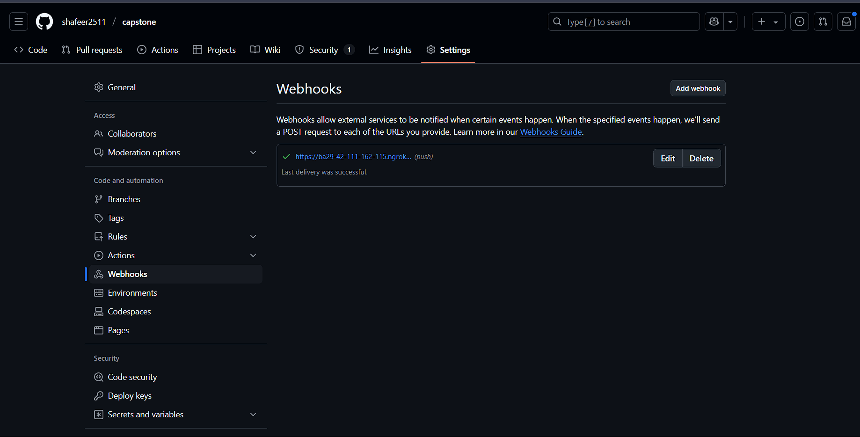

1. Tick the checkbox of GitHub hook trigger for GITScm polling in Jenkins.

**SCREENSHOT:**

